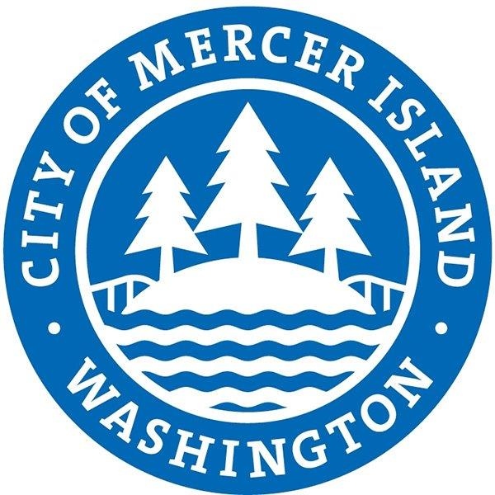
CITY OF MERCER ISLAND
PAYMENT REQUEST
ORIGINAL INVOICE MISSING / LOST

DATE:
EXPLANATION OF WHY ORIGINAL INVOICE IS MISSING
The following documentation is attached:
DUPLICATE INVOICE COPY
PROOF ORIGINAL INVOICE WAS NOT PREVIOUSLY PAID
PERSON REQUESTING PAYMENT
DIRECTOR APPROVAL

