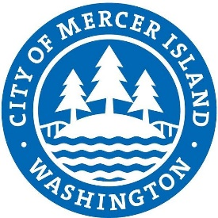
CITY OF MERER ISLAND
SURPLUS DECLARATION FORM

To dispose of unwanted property, fill this form out and return it to the Finance Department.

Department | Date
Location of Property | Staff Contact

Original Price | Estimated Value Today
Description of property to be surplused

Reason why property is no longer needed by the Department

Additional comments:

Approvals:

Department Director |  | Date:

City Manager: |  | Date:

Finance Director: |  | Date:

