City of Mercer Island
INCIDENT REPORT

INSTRUCTIONS:
- This report shall be completed by the employee who is on duty at the time of the incident with input provided by the person(s) who discovered and/or witnessed the incident immediately.
- If injury sustained by employee, also complete the Employee Injury/Illness Form.
- Return to your supervisor to route to the City Attorney’s Office within 48 hours of incident.

Person Completing Incident Report Form | Today’s Date: |  | Department:
Person Completing Incident Report Form | Employee or Volunteer Name: |  | Work Phone:
Person Completing Incident Report Form | Position Title: |  | Supervisor’s Name:
Person Involved in Incident | City Employee? | Yes No | If Yes, Department:
Person Involved in Incident | Name: |  | Supervisor’s Name:
Person Involved in Incident | Street Address: |  | Cell Phone:
Person Involved in Incident | City, State, Zip |  | Home Phone:
Person Involved in Incident | Is involved party over 18? | Yes No | If No, Date of Birth:
Witness Information | List the names of any witnesses and contact info (attach all witness statements to this form):
Witness Information | Name: |  | Phone:
Witness Information | Street Address: |  | City, State, Zip
Witness Information | Name: |  | Phone:
Witness Information | Street Address: |  | City, State, Zip
Witness Information | Name: |  | Phone:
Witness Information | Street Address: |  | City, State, Zip
Witness Information | Name: |  | Phone:
Witness Information | Street Address: |  | City, State, Zip

Incident/Accident Details | Incident Details
Incident/Accident Details | Date & Time of Incident: |  |  |  |  | Dept/City Facility
Incident/Accident Details | Exact Location of Incident:
Incident/Accident Details | If property damage only, then skip to Summary of Incident Section.
Incident/Accident Details | Personal injury? Yes No |  | If Yes, was medical treatment required? Yes No
Incident/Accident Details | Was 911 offered? Yes No |  | Was 911 called? Yes No
Incident/Accident Details | If medical treatment was required, what treatment was received, by whom was it administered, & date:
Incident/Accident Details | Was accident investigated by Police? Yes No |  |  |  | Report # (if known):
Incident/Accident Details | Name of the Police Department and/or Officer:
Incident/Accident Details | Summary of Incident
Incident/Accident Details | Please describe incident to best of your knowledge including assistance or active measures (if any) taken:
Property Damage | If property damage was sustained, please complete this section:
Property Damage | Private property damaged? Yes No |  |  | If Yes, type of property?
Property Damage | Describe damage (be specific):
Property Damage | City property damaged? Yes No |  |  | If Yes, type of property?
Property Damage | Describe damage (be specific):

Property Damage | If a vehicle was involved:
Property Damage | List specific damages to vehicle: | Please list the number(s) that correspond with the damage to the vehicle:  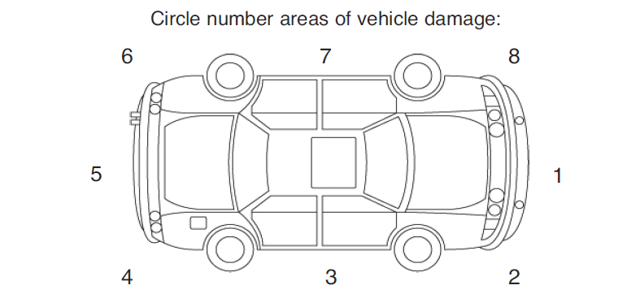

THIS SECTION TO BE COMPLETED BY CITY OF MERCER ISLAND EMPLOYEES ONLY!
Supervisor Review
The following supervisor is aware of the incident and has reviewed it with employee completing this form:
Supervisor Signature |  | Supervisor Name |  | Date
Manager/Supervisor Review
The following manager/supervisor has also reviewed this report:
Manager/Supervisor Signature |  | Manager/Supervisor Name |  | Date
Director Review
The following director has also reviewed this report:
Director Signature |  | Director Name |  | Date

WITNESS STATEMENT
Please attach all witness statements to the Incident Report Form

Witness Information | City Employee? |  | Yes No | If Yes, Department:
Witness Information | Name: |  |  | Phone:
Witness Information | Street Address: |  |  | City, State, Zip
Witness Information | Is involved party over 18? |  | Yes No | If No, Date of Birth:
Witness’s description of the incident:

Witness Signature: |  |  |  |  |  |  | Date:

