Employee Self-Review Form
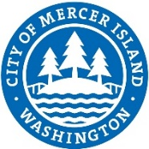

Employee Name:
Job Title:
Supervisor Name:
Evaluator Name:
Evaluation Period: |  | to
The purpose of this form is to capture an employee’s successes over a single evaluation period. Please answer the questions below and return to your supervisor at least one week before your scheduled performance evaluation meeting.
Of what accomplishments, contributions and skills acquired during the last evaluation period are you particularly proud?
What suggestions do you have that would help you provide better service to customers or make you more effective in your job?
What are your training or development goals over the next evaluation period?
In appraising your performance, are there any other persons with whom your supervisor should speak to get a more complete picture of how you do your work and/or get results?

Employee Signature: |  | Date:

