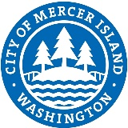 | Objectives, Projects & Goals Development Form

Employee Name:
Job Title:
Type of Review:
Evaluator Name:
Evaluation Period: |  | to
This form establishes clear performance guidelines and expectations for the employee. Job duties and expectations are not limited to the objectives listed below.
Performance Objectives - Criteria
Job Related Projects - Criteria
Continuous Learning / Professional Growth - Goals
Signatures

By signing below, the parties involved indicate that the above performance criteria have been discussed. It also indicates that the employee understands that the results of the above criteria will be discussed during the employee’s next performance review. The employee is being provided with a copy of this document for his/her records.

Employee Signature: |  | Date:

Supervisor Signature: |  | Date:

Director Signature: |  | Date:

